Hangman:

Front-end:
Left section: Picture section to display images add one section of image by one error
Right section: top the word hidden
Hint
User lives
Alphabet buttons

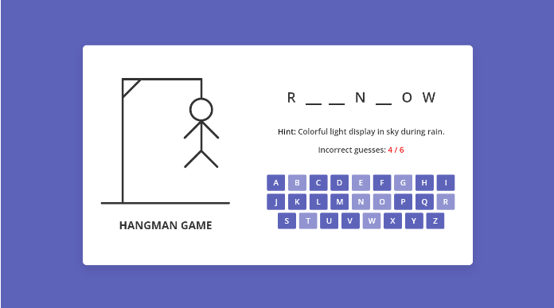
Inspiration design

Back-end :

Have a list of words with the hint in object format
{word, hint}
- when page load select a word, hint from the list and add it to the operation
- display the hint in the located section.
- the image section have to be empty
- if the user clicked a letter check if there is a semeler letter in the selected word if yes display the letter in the word section and disable the button letter
- if the user clicked the letter and there is not letter simeller in the word minis the live the use have
- if the user run out of lives show a message with the correct word and try again button and by clicking restart the page
- when the page restarts select a new word,hint and start from 1

